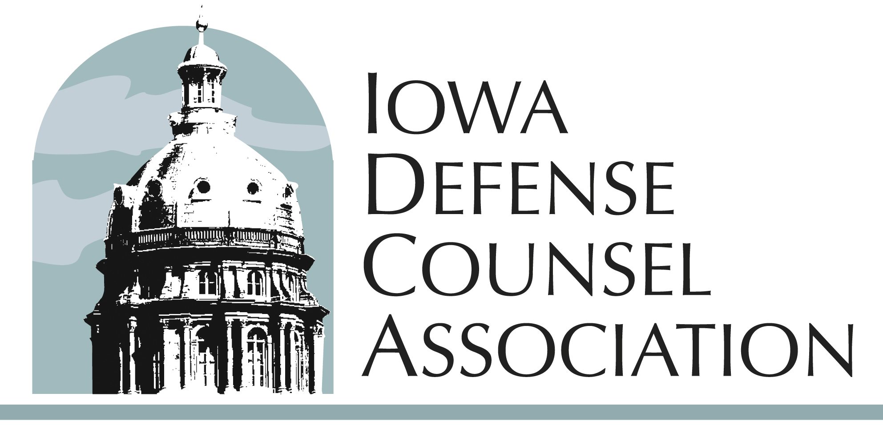

IDCA Annual Business Meeting
September 18, 2025
12:00 p.m.
Prairie Meadows Event Center
Altoona, IA

- Call to Order Sealey
- Approval of IDCA Nominations Report Sealey
- Adjourn Sealey

IDCA Nominations Report

The Iowa Defense Counsel Association’s Nominating Committee puts forth to the IDCA voting members the following nominees for the 2025–2026 year:

President (Term: 2025–2026)
Sean M. O’Brien
Dickinson Bradshaw
Des Moines, IA

President-Elect (Term: 2025–2026)
Jon Vasey
Elverson Vasey
Des Moines, IA

Secretary (Term: 2025–2026)
Joshua Strief
Elverson Vasey
Des Moines, IA
Treasurer (Term: 2025–2026)
Jace T. Bisgard
Shuttleworth & Ingersoll PLC
Cedar Rapids, IA

District V (Term: 2025–2028)
Apryl M. DeLange
Hopkins & Huebner
Des Moines, IA

District VI (Term: 2025–2028)
Corinne R. Butkowski
Gray, Stefani & Mitvalsky
Cedar Rapids, IA

District VII (Term: 2025–2028)
Brandon Lobberecht
Betty Neuman McMahon
Davenport, IA
New Lawyer Representative (Term: 2025-2028)
Spencer Vasey Dirth
Elverson Vasey
Des Moines, IA
DRI Representative (Term: 2025-2028)
Brenda Wallrichs
Lederer Weston Craig
Cedar Rapids, IA

